CURRICULUM VITAE

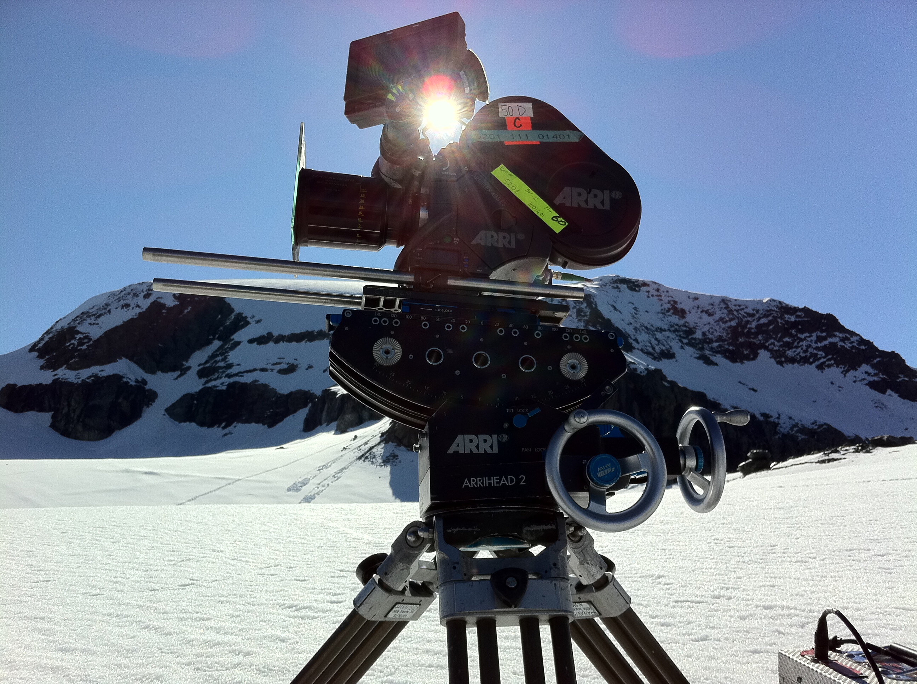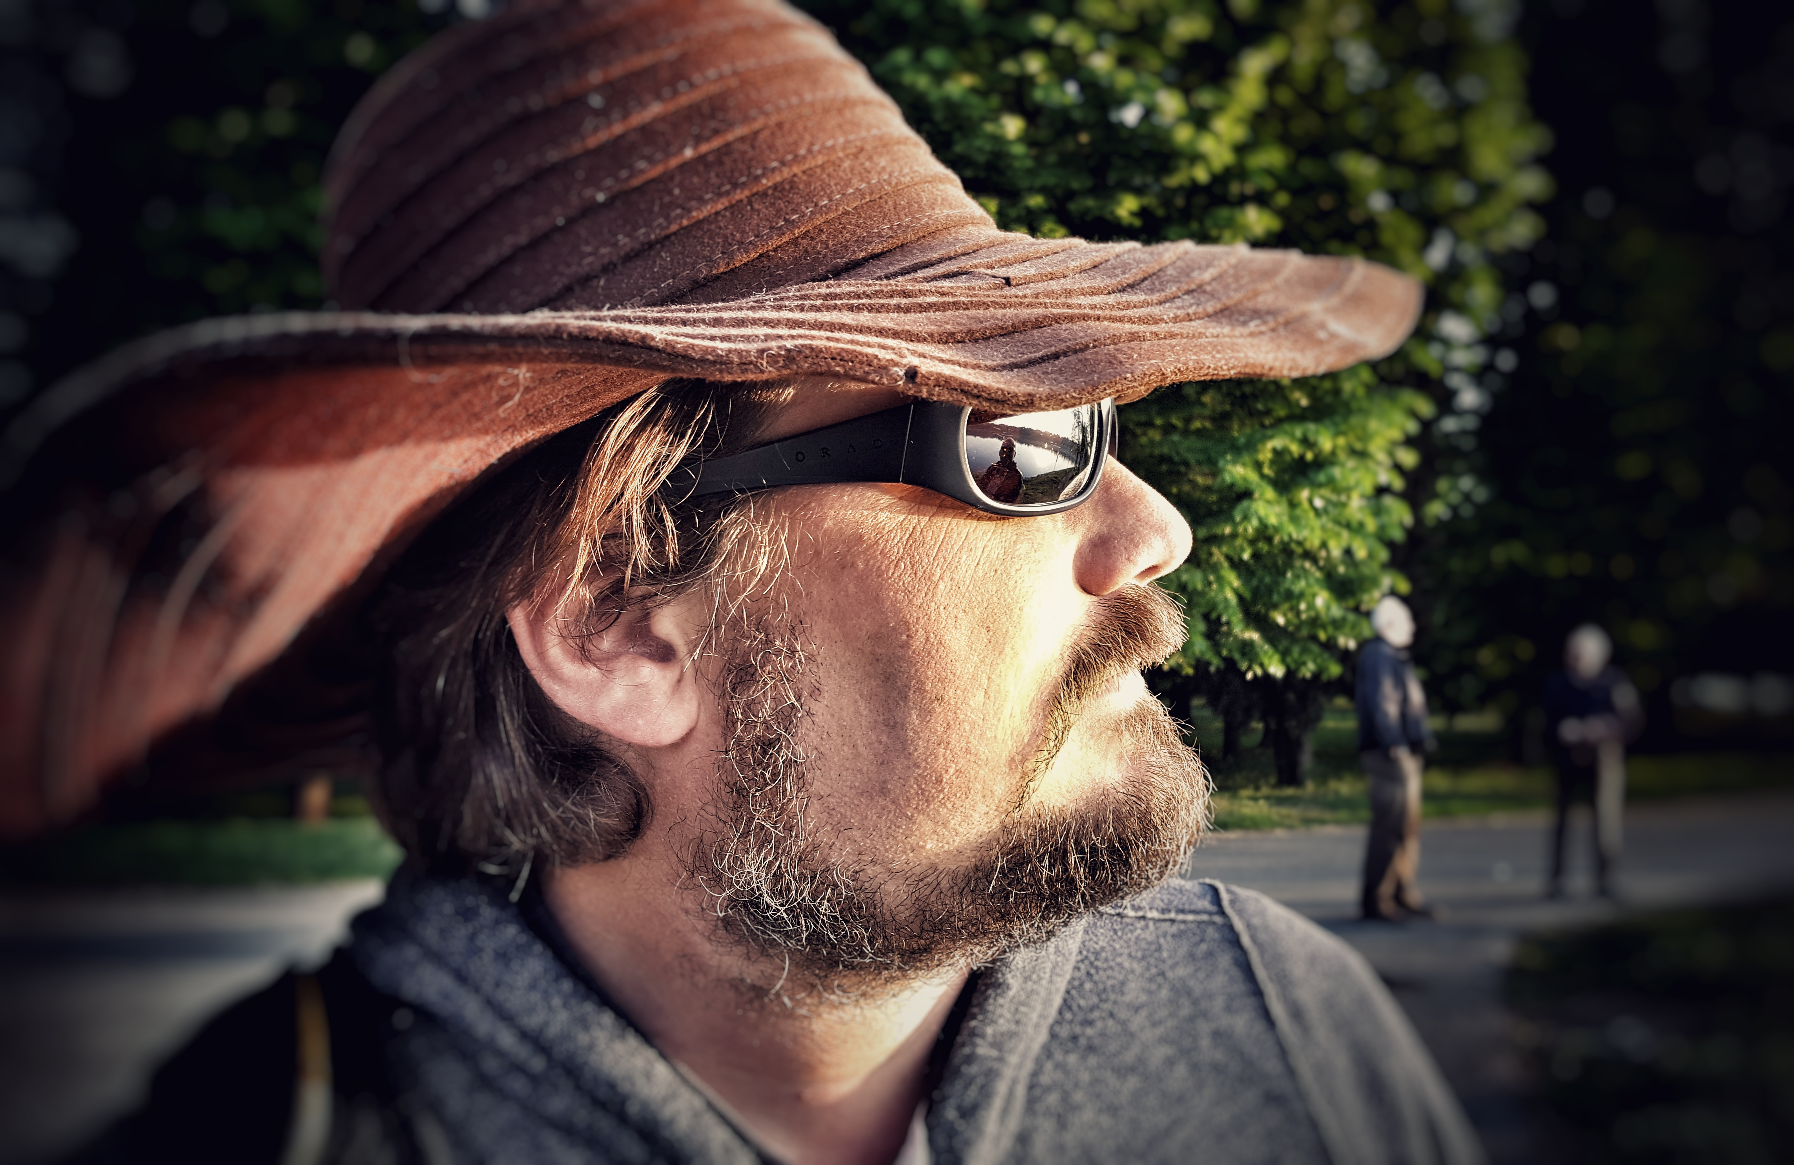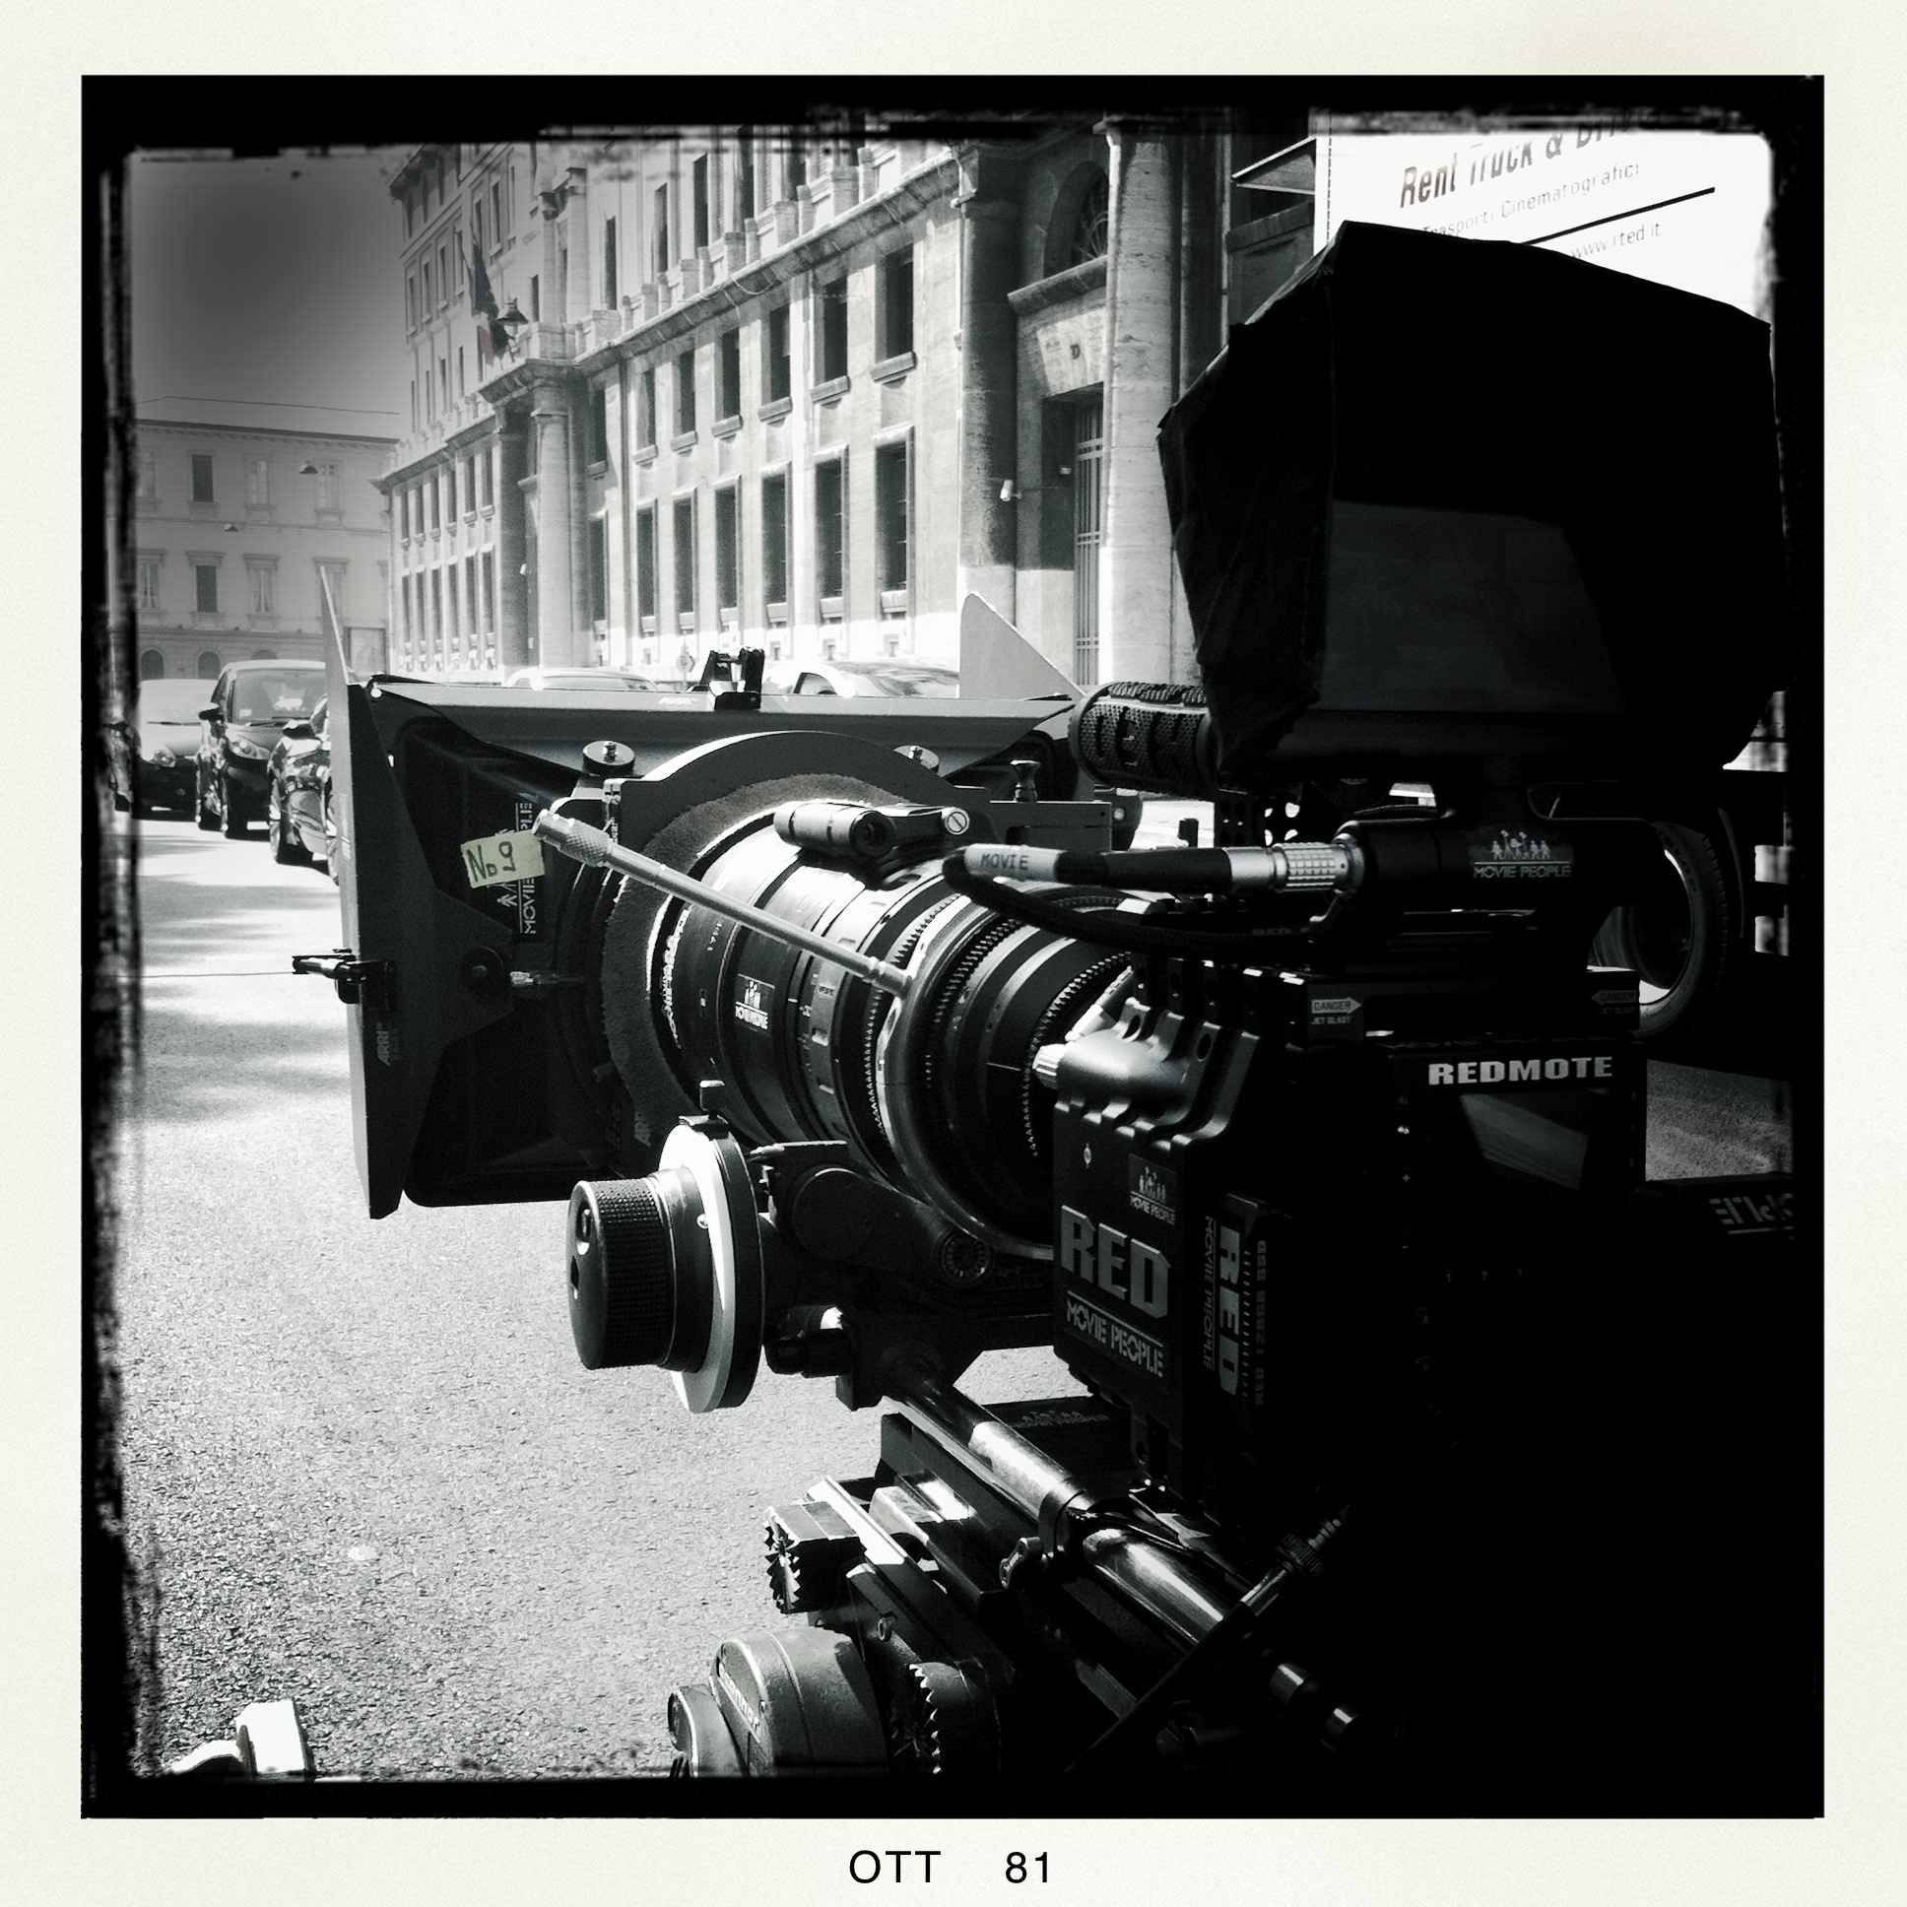
LOADER
SECOND AC
MARCO ANGELONI
Mobile: 0039335348846
marcoangeloni60@yahoo.it

Responsible specialized technician of High Speed 35mm Camera for Technovision rental in Milan Italy from 2001 to 2004.

PRODUCT DIRECTOR PHOTOGRAPHER
SAAB | DANIEL BARBER | STEPHEN BLACKMAN
VISA | DANIEL BARBER | STEPHEN BLACKMAN
COCA COLA | TONY KAYE | TONY KAYE
PEUGEOT | MICHAEL DOWNING | DAVID UNGARO
HSBC | IVAN ZACHARIAS | JAN VELICKY
COORS | RORY KELLEHER | DARRAN TIERNAN
ALFA 156 | LUCA MARONI | ALESSANDRO BOLZONI
RENAULT | DOM & NIC | ALEX BARBER
UPS | DOUG FOSTER | SIMON RICHARDS
NESPRESSO | BENNETT MILLER | RODRIGO PRIETO
NESTLÈ | VINCENT SQUIBB | JAN FOSTER
LEXUS | DANIEL BARBER | ALEX MELMAN
ROC | MURIEL LACALMONTIE | DAVID NISSEN
YAMAHA | LUCA MARONI | ALESSANDRO BOLZONI
GOODFELLA’S | SAM CADMAN | STEVE KEITH-ROACH
MEDIASET PREMIUM | ANGEL GRAZIA | HARIS ZAMBARLOUKOS
BMW X5 | DANIEL BARBER | STEPHEN BLACKMAN
FERRERO | JEAN-PAUL SEAULIEU | ERIC DOUMAGE
VW GOLF GTI | TONY KAYE | TONY KAYE
BACARDI | JOE ROMAN | ROBBIE RYAN
VODAFONE | FREDERIC PLANCHON | PHILIPPE LESOURD
MARK & SPENCER | JOE ROMAN | ROBBIE RYAN
LEXUS | DANIEL BARBER | JOHN LYNCH
MULINO BIANCO | KIRK JONES | JAN FOSTER
MULINO BIANCO | BABAK | JAN RICTHER-FRIS
NIKE | STEVE KEITH-ROACH | STEVE KEITH-ROACH
SAP | DANIEL BARBER | JOHN PEREZ
PAVESINI | ANDERS HALLBERG | MARTIN AHLGREN
MULINO BIANCO | NIKOLAI KARO | DIETER DEVENTER
MEDIPHARMA | BRITTA MANGOLD
ZAIN | MATTHIAS ZENTNER | TORSTNER LIPPSTOK
BMW X5 | DANIEL BARBER | ALEX BARBER
FIAT PUNTO | LUCA MARONI | STEPHANE VALLEE
PASTA RONI | COLIN GREGG | PHIL MEHUEX
SHELL | DANIEL BARBER | STEPHEN BLACKMAN
EAU JEUNE | OLIVER DAHAN | OLIVER CARIOU
IMETEC | KARINA TAIRA | RIEGO VAN WERSCH
MULINO BIANCO | ELI SVERDLOV | EMANUEL KADOSH
CARTIER | BRUNO AVEILLAN | PATRICK DUROUX
MEDIASET PREMIUM | AXEL LAUBSCHER | ANDRES BERGER
MARSEILLAIS | ERIC LARTIGAU | DAVID UNGARO
GROUPAMA | IVAN GOLDSCHMIDT | DAVID NISSEN
DUCATI M.STRADA 1200 | EKKEHART POLLACK | EKKEHART POLLACK
MEDIASET PREMIUM | RONALD SCALPELLO | UMBERTO MANENTE
TELECOM | ALESSANDRO DALATRI | AGOSTINO CASTIGLIONI
MACDONALD’S | JOHN IMMESOETE | RENATO ALFARANO
COCA COLA | GIUSEPPE TORNATORE | RENATO ALFARANO
LEXUS | DANIEL BARBER | BRENDAN GALVIN
LEXUS | DANIEL BARBER | BEN DAVIS
GUINNESS | JONATHAN GLAZER | IVAN BIRD
RENAULT ESPACE |  | MANDIE WALKER
SKY | SALMON | ALBERT ROIGE
ALPEN | TONY BARRY | SEAN BOBBIT
WORTHINGTON | JOE ROMAN | SIMON CHAUDOIR
TOYOTA IQ | DANIEL BENMAYOR | PACO FEMENIA
VIDEO MADONNA | JONAS AKERLUND | ERIC BROMS
COOP | AUGUSTO ZAPIOLA | JAVIER JULIA
LIEKEN | STEF VIAENE | ALESSANDRO BOLZONI
VODAFONE | AUGUST BALDRUSSON | OTTAR GUDNASON
PEUGEOT 307 CC | FREDERIC PLANCHON | PATRICK DUROUX
PEUGEOT 307 | PEDRO ROMHANYL | JOHN PEREZ
BARILLA | JAVIER BLANCO | UMBERTO MANENTE
SONY | VERNIE YEUNG | MATIAS MONTERO
BMW M3 | EDWARD BERGER | MICHAEL MEIKE
STELLA ARTOIS | JONATHAN GLAZER | STEVE KEITH-ROACH
AUDI |  | JOHN DE BORMAN
BREIL |  | EDUARDO SERRA
MICROSOFT | ANDREW DOUGLAS | ANDREW DOUGLAS
ADIDAS | ANDREW DOUGLAS | ANDREW DOUGLAS
VOLVO V70 AWD | PATRICHA MURPHIE | IVAN BIRD
VOLVO C70 |  | JOHN MATHIESON
AGIP | FRANCO ZEFFIRELLI | RONNYE TAYLOR
RENAULT CLIO | BOB BROKS | PETER SUSCHITZKY
AUDI R8 | BRUNO AVEILLAN | OLIVER COCOUL
COCA COLA | JAN DE BONT | JAN DE BONT
SUPERGA | TARSEM | PAUL LAUFER
SONY | ZHANG YIMOU
UBS | WIM WENDERS | CHRISTOF WAHL
YOMO | LEO SOLANES | ALESSANDRO BOLZONI
WIND | MARCELLO CESENA | AGOSTINO CASTIGLIONI
COSTA CROCIERE | GIUSEPPE CAPOTONDI | TAT RADCLIFFE
CERRUTI | KARINA TAIRA
MACDONALD’S |  | JEAN POISSON
COORS | SIMON COLE | HARIS ZAMBARLOUKOS
CARTIER | BRUNO AVEILLAN | PATRICK DUROUX
GALBUSERA | FRAN TORRES | JUANMI AZPIROZ
FERRERO | ALEJANDRO TOLEDO | PACO FEMENIA
UBS | WIM WENDERS | MARK PATTEN
VODAFONE | GIUSEPPE CAPOTONDI | JUANMI AZPIROZ
MULINO BIANCO | ELI SVERDLOV | EMMANUEL KADOSH
PASTA AGNESI | FABRIZIO MARI | MANFREDO ARCHINTO
LOUIS VUITTON | ROMAIN GALVES | KASPER TUXEN
AZZARO | JONAS AKERLUND | ERIC BROMS
OPEL ADAM | MATTHAUS BUSSMANN | EKKEHART POLLACK
AUDI LAND OF 4 | ALBERTO COLOMBO | ALESSANDRO BOLZONI
TOUCH OF CRUDE | NICOLAS WINDING REFN | MAGNUS JONK
GRAN PAVESI |  | TOMMASO TERIGI
HEINEKEN |  | AMILCARE CANALI
MASERATI | FERZAN OZPETEK | FABRIZIO ACETULLI
BUCCELLATI | JOSH OLINS | PETER SZOELLOSI
BIRRA MORETTI | ALI ALI | YVES SEHNAOUI
PRADA |  | MANFREDO ARCHINTO
VINCERE | MARCO BELLOCCHIO
IL COSMO SUL COMO’ | MARCELLO CESENA | AGOSTINO CASTIGLIONI
 | PAOLO GENOVESE | GIOVANNI FIORE COLTELLACCI
THE INTERNATIONAL | TOM TYWER | FRANK GRIEBE
CADO DALLE NUBI | GENNARO NUNZIANTE | LORENZO ARODISIO

